**THE INCREASING INFLUENCE OF LEADERS OF PERSONS WITH DISABILITIES TOWARDS DISABILITY INCLUSION IN NWOYA DISTRICT**

Following the trainings and mentorship support of [VNG International](https://www.vng-international.nl/)/[We Are Able Programme](https://weareable.ngo/en/) to Councillors representing Persons with Disabilities on agenda setting, legislation and following up on issues affecting Persons with Disabilities in 2022, Hon. Apiyo Jenifer Lagweno, while addressing leaders of disability-inclusive savings groups in [Nwoya district](https://nwoya.go.ug/publications/nwoya-district-disability-database) in September 2024 said that she is happy with the far she has come in her work. Hon. Apiyo now reports to feel very assertive and can speak boldly especially about the need for inclusive food security for people with disabilities.

The enhanced capacities of Leaders of Persons with Disabilities contrast with Hon. Apiyo and her colleagues’ inadequate performance in the District Local Government Councils 2 years back, as noted by the Speaker of Nwoya District Local Government Council. The general feeling expressed at the then WaA! Programme Kick-off meetings in August 2021 was that, the Political Leaders representing Persons with Disabilities in the District Local Government Councils were largely not adequately raising issues affecting their constituents but rather were more confrontational than dialoging while relating with the appointed local authorities staff and fellow Political Leaders in the Local Governments.

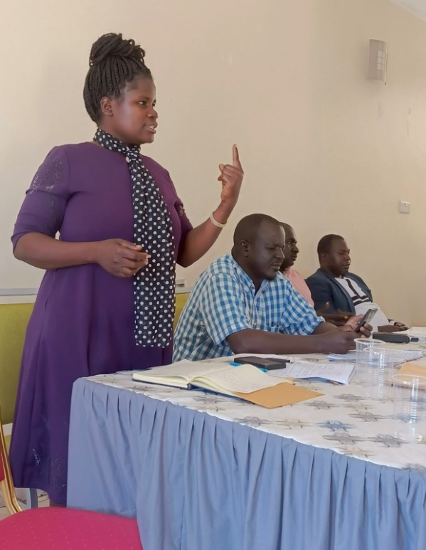However, with the numerous participation in joint monitoring visits to households of persons with disabilities participating in [Participatory Integrated household Planning (PIP)](https://www.enableme.ug/en/article/sustainable-land-management-for-food-security-amongst-persons-with-disabilities-through-integrated-farm-plan-pip-10411) and [Inclusive Savings (ISAVE)](https://nad.nhf.no/nads-development-work/resources/economic-empowerment-resources/uganda-isave-manual/), in addition to receiving trainings on Inclusive Governance, Disability Inclusion, Design and Implementation of [disability-Local Inclusion Agenda (LIA)](https://weareable.ngo/en/news/the-development-of-local-inclusion-agenda/), the application of Local Government Council Rules of Procedures, spontaneous mentorship support from WaA! Programme staff coupled with an induction training from Ministry of Local Government, the Speaker of Nwoya District Local Government currently repots of improvements in the performance of Hon. Apiyo Jennifer Lagweno and fellow Councillor representing Persons with Disabilities. The reported improvements are inform of better quality debates in District Council meetings and better collaboration with other Public Authoritiess, the local OPDs and fellow political leaders while following up on concerns raised by Persons with Disabilities.

These improvements in capacity of Leaders of Persons with Disabilities – including that of Hon. Apiyo Jennifer Lagweno to influence agenda setting and members of the District Council, according to the Vice Chairperson of Nwoya district Local Government Council, has made it possible for the District’s LIA frameworks and budgets to be overwhelmingly approved by all members of the District Council in November 2023.

The improvements in the capacities of Leaders of Persons with Disabilities is currently reflected in the general positive change towards prioritizing agenda issues of Persons with Disabilities in the District Local Government as evidenced by the increase in the number of policy makers positively supporting the course of disability inclusion. As reported by Hon. Apiyo, 24 more policy makers in the district local Government Council are now allies of leaders of Persons with Disabilities…In 2021 we were 2 representatives of Persons with Disabilities elected to the District Council but now we are 26 in number because of our successful influence, said Hon. Apiyo.

Hon. Apiyo Jennifer Lagweno is a disability inclusion Community Champion leading the implementation of disability-inclusive Local Inclusion Agenda aimed at enabling Persons with Disabilities achieve food and nutrition security in Nwoya District by the year 2025. Hon. Apiyo has physical impairment.