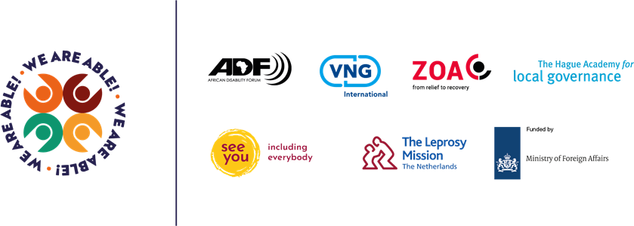

WE ARE ABLE!
DRAFT REPORT ON PROFILING STUDY FOR SITUATION OF PERSONS WITH DISABILITY IN NWOYA DISTRICT, MARCH 2022
- DISTRIBUTION OF THE RESPONDENTS BY GENDER AND LOCATION (PARISH)
The study was conducted in all the 46 Parishes in Nwoya District (Northern Uganda). A total of 3,025 respondents (PWDs) participated in the study out of the expected 3,690 PWDs. This represents 82% of total estimated number of PWDs in the 123 villages/cells of Nwoya district. The distribution of these respondents across the locations (Parishes) is shown in the Table in Appendix 1.
In terms of gender, the respondents were more or less equally distributed as shown in Table 1 and Pie chart below. The male constituted 46.0% of the respondents while the 54.0% were female. The gender of 5 respondents was not determined.
TABLE SHOWING DISTRIBUTION OF RESPONDENTS BY GENDER
 | Male | Female | Total
Count | 1,393 | 1,627 | 3,020
% of the Respondents | 46.00% | 54.00% | 100.00%

.

THE PIE CHART SHOWING THE DISTRIBUTION OF RESPONDENTS BY GENDER
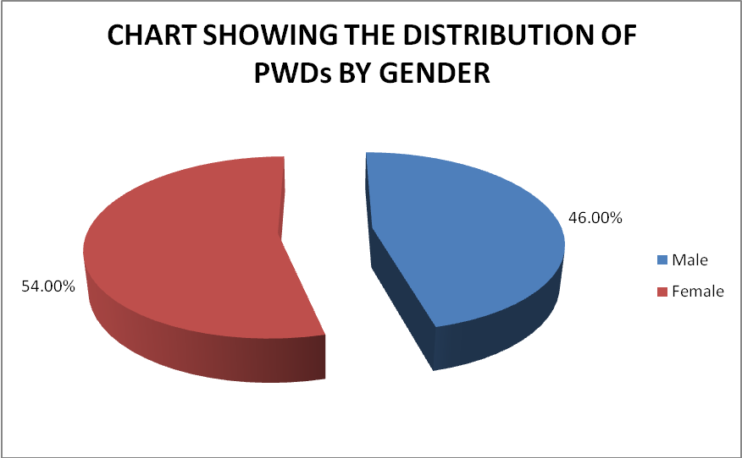
- AGE GROUP OF THE RESPONDENTS
The respondnets were asked to report on their exact ages and these were grouped into six age groups as shwon in the table and Bar Graph below. The findings were found to vary from parish to parish as shown in the table in Appendix 2. However, the overall findings are shown in the table and Bar Chart below.
TABLE SHOWING THE AGE-GROUPS OF RESPONDENTS
Age-groups | 0 - 12 Years Old | 13 - 21 Years Old | 22 - 35 Years Old | 36 - 50 Years Old | 51 - 66 Years Old | 67 + Years Old | TOTAL
Count | 569 | 501 | 425 | 534 | 516 | 476 | 3,021
% of the Respondents | 18.83% | 16.58% | 14.07% | 17.68% | 17.08% | 15.76% | 100.00%

BAR GRAPH SHOWING AGE-GROUPS OF PWDs IN NWOYA DISTRICT
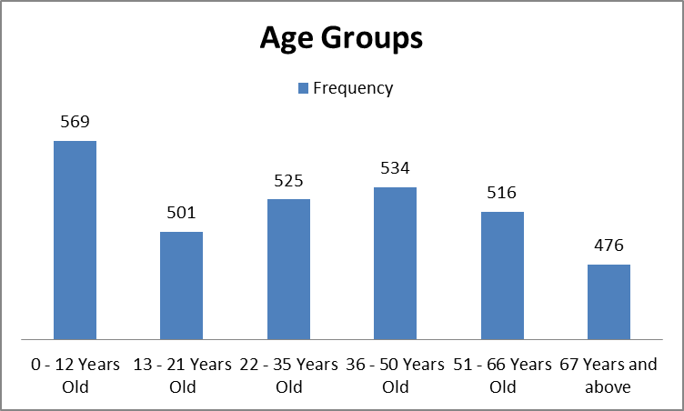
A total of 3,021 out of 3,025 respondents were able to disclose their ages. From the Table and Bar graph above, the respondents were found to be more or less evenly distributed in the various age-groups. However, those in the youngest age group (0 – 12 years) constituted the majority (18.8%) of the total respondents. Meanwhile, those in the 22-35 age group were the least, constituting only 14.1%.
- HIGHEST LEVEL OF EDUCATION
The PWDs in Nwoya District were also asked to report on the highest level of education that they had attained by the time of conducting the study. The detailed findings were found to vary from home parish to home parish as shown in the table in Appendix 3. However, the overall findings were shown in the table and Bar Chart below.
TABLE SHADOWING THE HIGHEST LEVEL OF EDUCATION ATTAINED BY PWDS
Highest Level of Education
 | COUNT | % of Total Respondents
None | 1,199 | 39.6%
Primary Leaving | 1,547 | 51.2%
Secondary (O Level) | 210 | 6.9%
Secondary (A ’Level) | 24 | 0.8%
Post-Secondary (Certificate) | 17 | 0.6%
Post-Secondary( Diploma) | 22 | 0.7%
Graduate | 5 | 0.2%
TOTAL | 3,024 | 100.0%

BAR GRAPH SHOWING THE HIGHEST LEVEL OF EDUCATION ATTAINED BY PWDs IN NWOYA DISTRICT
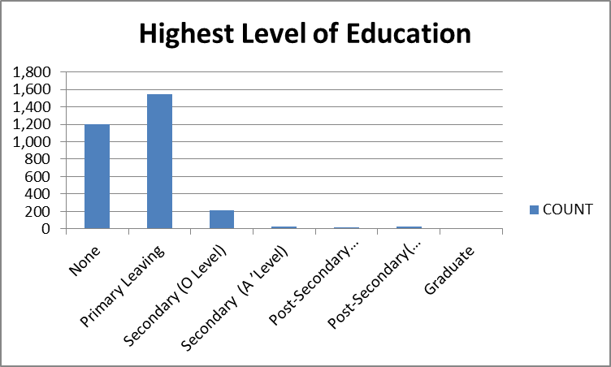
The Table and the Bar Graph above show that the majority of the respondents (51.2%) did attain the Primary Leaving level of education. Meanwhile, this was followed by those who did not attain any level of education (39.6%). In other words, these are people with disabilities who never went to school in their entire lives. And those who attained Ordinary level (UCE) were 6.9%. Other levels of education registered less than 1% each.
- MARITAL STATUS OF THE RESPONDENTS
The study also sought to establish the marital status of the respondents. Accordingly, the respondnets were asked to report whether they were married or not married. Their responses by Home Parish is shown in the Table in Appendix 4. In summary, it was found that the married were 1,567 (899 females and 668 males). More females (9) than males (3) in the age bracket of 13-21years were married across the district. No person with a disability in the age bracket of 0 – 12 years old was established to be married.

- THE NUMBER OF CHILDREN OF PWDs
The PWDs were also asked to report on the number of children they had by the time of the study. These were grouped into three categories as shown in the Table below. The findings were found to vary from parish to parish as shown in the table in Appendix 5.

TABLE SHOWING THE NUMBER OF CHILDREN BORN TO PWDs
Number of children | 0 -3 Children | 4 - 7 Children | 8 Children and above | Total
Count | 1,431 | 1,363 | 189 | 2,983

PIE CHART SHOWING THE NUMBER OF CHILDREN OF PWDs
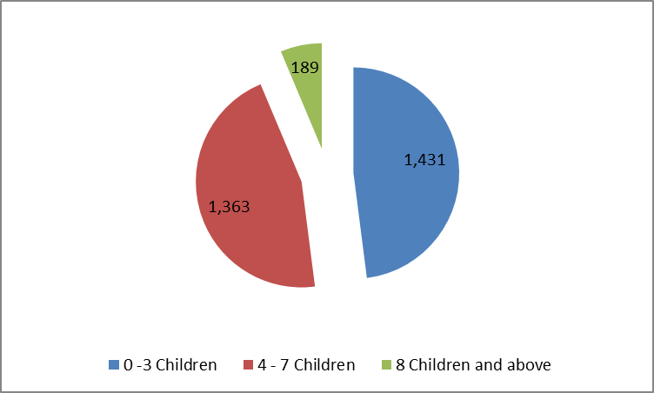
Overall, it was found that those who had 0-3 children were 1,431 in number. This was followed by those who had 4-7 children (1,363). Meanwhile, those who had more than 7 children were 189 in total.

- SCHOOLING STATUS OF CHILDREN OF PWDs
The study also sought to find out whether the children born to PWDs in Nwoya District were attending school or not. The findings were found to vary from parish to parish as shown in the table in Appendix 6. However, the overall results show that 70.4% of the PWDs (with children of school going ages) reported that their children were schooling while 29.4% reported that their children were not attending school.

- PWDs WHO ARE HOUSEHOLD HEADS
The study also sought to find out whether some of the PWDs in Nwoya District were heads of households. The findings were found to vary from parish to parish as shown in the table in Appendix 7. However, the overall results show that 1,453 of the PWDs are heads of households.

- HOLDING OF NATIONAL IDENITITY CARDS
The study also sought to find out whether PWDs in Nwoya District were holders of National Identity Cards. The findings were found to vary from parish to parish as shown in the table in Appendix 8. However, the overall results show that 1,278 representing 42.2% of the PWDs were holding the National Identity Cards while 1,748 representing 57.8% were not holding the National Identity Cards.

- FORMS OF DISABILITY
The study sought to establish the different forms of disability prevelent in the area or diastrict where the study was conducted. The different froms of disability were found to vary from parish to parish as shown in the Table in Appendix 9. However, the overall findings are shown in the table and Bar Chart below.
TABLE SHOWING THE SUMMARY OF THE FORMS OF DISABILITY
 | Form of disability
FORM OF DISABILITY | COUNT | % of Total Respondents
Albinism | 1 | 0.03%
Deaf-Blind | 239 | 7.92%
Epilepsy | 349 | 11.56%
Hearing impairment | 186 | 6.16%
Mental retardation | 259 | 8.58%
Physical impairment | 1481 | 49.07%
Spine damage | 45 | 1.49%
Persons of Short Stature (Little persons) | 21 | 0.70%
Visual impairment | 437 | 14.48%
TOTAL | 3,018 | 100.00%

BAR CHART SHOWING FORMS OF DISA BILITY
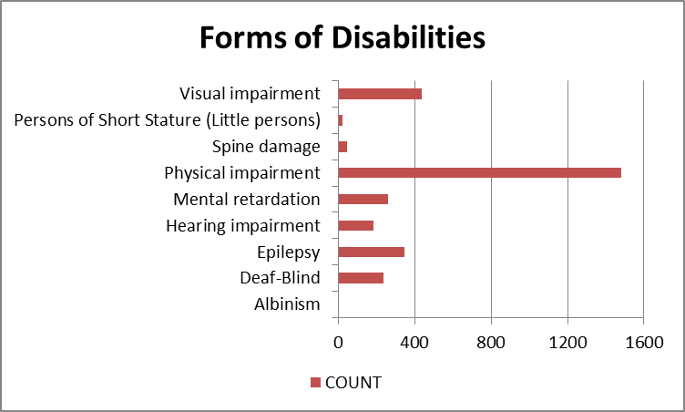
The Table and the Bar Chart above reveal that persons with all forms of disability are found in Nwoya District. However, physical impairement is the most prevalent form of disability (49.1%) followed by visual impairement (14.5%) and epilepsy (11.6%). Meanwhile, the least prevelent forms of disability were found to be albinism (0.0%) and persons of Short Stature (0.7%).
10. MAIN CAUSES OF THE DIFFICULTY
The respondents were asked to report on the main cause of their difficulty. The causes of difficulty were found to vary from parish to parish as shown in the Table in Appendix 10. However, the overall findings are shown in the table and Bar Chart below.
TABLE SHOWING THE MAIN CAUSES OF DIFFICULTY
 | What was the MAIN cause of the difficulty?
MAIN CAUSE OF THE DIFFICULTY | COUNT | % of Total Respondents
Born Like This | 895 | 30.4%
Work-Related Accident | 83 | 2.8%
Street/ Traffic Accident | 212 | 7.2%
Other Accident | 490 | 16.6%
Work-Related Disease | 83 | 2.8%
Non-Work-Related Disease | 952 | 32.3%
Age Related Disease | 110 | 3.7%
Don't Know | 118 | 4.0%
TOTAL | 2,943 | 100.0%
BAR CHART SHOWING THE MAIN CAUSE OF DIFFICULTY IN PWDs
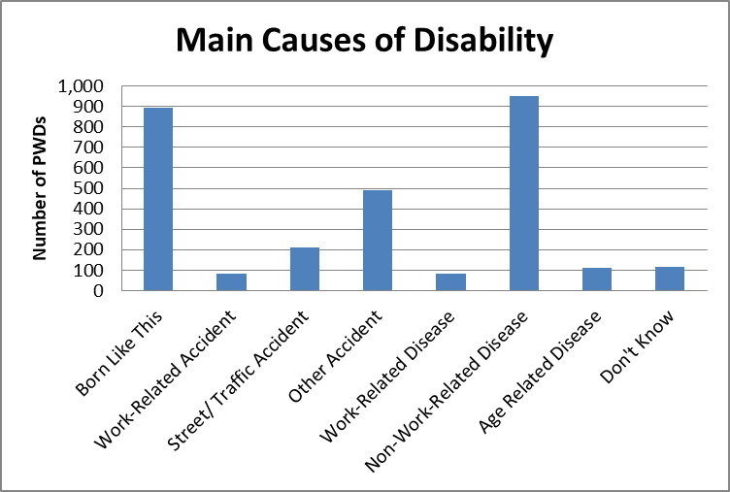
From both the Table and the Bar chart, Non-Work-Related Diseases accounted for 31.9% closely for by natural cause of difficutly (born like this) which accounted for 32.3%. meanwhile, the least causes of diffulcty were reported to be Work-Related Accident (2.8%), Work-Related Disease (2.8%) and Age Related Disease (3.7%).
- EXTENT OF DIFFICULTY IN SELF-CARE
The study also asked the respondents to report on the extent of difficlty that they faced as a result of their disability. Again, this was found to vary from parish to parish as shown in the Table in Appendix 11. However, the overall findings are shown in the table and Bar Chart below.
TABLE SHOWING THE EXTENT OF DIFFICULTY IN SELF-CARE
 | Difficulty in self-care due to the disability |  |  |  |  | Total
 | No Difficulty | Some Difficulty | A Lot Of Difficulty | Cannot do At All | Don't Know | Total
Count | 298 | 1,360 | 1,209 | 145 | 12 | 3,024
% of the Respondents | 9.85% | 44.97% | 39.98% | 4.79% | 0.40% | 100.00%
From the table above, nearly 45.0% of PWDs reported that they faced some difficulty and 40% reported that they faced a lot of difficulty. Only 9.9% reported that they did not face any difficulty due to their disability. 145 PWDs (representing 4.9%) reprted that they can not do anything at all interms of self care.
12. DIFFICULTY DUE TO THE DISABILITY (EVEN WHILE USING THE AID E.G FOR HEARING, SEEING, WALKING ETC.)
The study also asked the respondents to report on the difficlty that they faced as a result of their disability (even while using the aid e.g for hearing, seeing, walking etc.). Again, this was found to vary from parish to parish as shown in the Table in Appendix 12. However, the overall findings are shown in the table and Bar Chart below.
TABLE SHOWING DIFFICULTY DUE TO THE DISABILITY (EVEN WHILE USING THE AID E.G FOR HEARING, SEEING, WALKING ETC.)
 | Difficulty in self-care due to the disability even when using an aid/devise |  |  |  |  | Total
 | No Difficulty | Some Difficulty | A Lot Of Difficulty | Cannot do At All | Don't Know | Total
Count | 361 | 1,083 | 1,028 | 231 | 322 | 3,025
% of the Respondents | 11.93% | 35.80% | 33.98% | 7.64% | 10.64% | 100.00%

PIE CHART SHOWING DIFFICULTY DUE TO THE DISABILITY (EVEN WHILE USING THE AID E.G FOR HEARING, SEEING, WALKING ETC.)
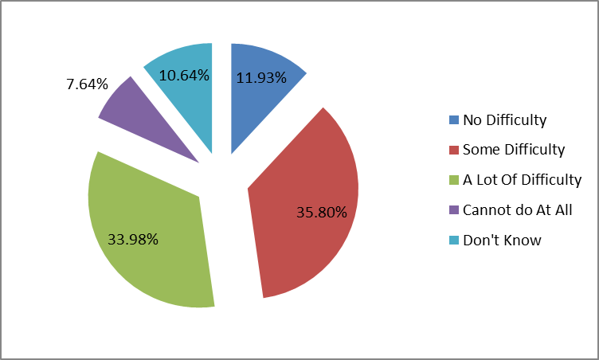
From the table and pie chart above, 35.8% reported that even while using the aid e.g for hearing, seeing, walking etc they faced some difficulty and 33.9% reported that they faced a lot of difficulty. Only 7.6% reported that they were unable to do anything at all in terms of their self care even with assistive aids. 11.9% reported that they did not face any difficulty due to their disability even while using the aid e.g for hearing, seeing, walking etc.
13. RECEIVING OF ANY GOODS OR SERVICES LINKED TO YOUR DISABILITY
The respondents were also asked to report on whether or not they received any goods and/or services linked to their disability and on the sources. Again, this was found to vary from parish to parish as shown in the Table in Appendix 13. However, the overall findings are shown in the table and Bar Chart below.
Table showing the receiving of goods and/or services and their sources
 | Do you receive any goods or services linked to your disability? |  |  |  |  |  | Total
 | None at all | Yes, mainly from Government | Yes, mainly from NGOs/CBOs | Yes, mainly from well wishers | Yes, mainly from religious institutions | Yes, mainly from family and friends | Total
Count | 1840 | 100 | 61 | 22 | 16 | 875 | 2914
% of the Respondents | 63.1% | 3.4% | 2.1% | 0.8% | 0.5% | 30.0% | 100.0%

PIE CHART SHOWING RECEIVING OF GOODS AND SERVICES
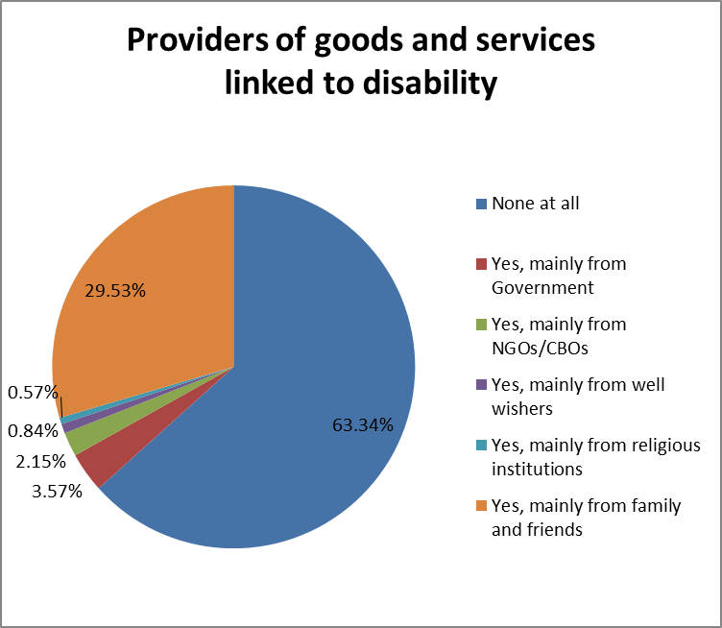
From both the table and bar graph above, it was noted that the majority (63.3%) of the respondents reported that they never received any goods or services from any source. Meanwhile, 29.5% reported having received goods or services mainly from family and friends. A small proportion reported to have received goods or services from government and from NGOs ( 3.6% and 2.2% respectively).
14. SPECIFIC HELP NEEDED BY PWDs
The study sought to find out from the PWDs which specific help that they needed most. Again, this was found to vary from parish to parish as shown in the Table in Appendix 14. However, the overall findings are shown in the table and Bar Chart below.
TABLE SHOWING THE SPECIFIC HELP NEEDED BY PWDs
 | Thinking about your daily needs, what specific help do you need?
 | COUNT | % OF RESPONDENTS
Visual Aid | 99 | 3.27%
Mobility Aid | 263 | 8.69%
Hearing Aids | 43 | 1.42%
Housing | 299 | 9.88%
Livestock | 472 | 15.60%
Farming Inputs | 169 | 5.59%
Land | 68 | 2.25%
Financial Aid | 567 | 18.74%
School Fees | 292 | 9.65%
Medical Assistance | 402 | 13.29%
Skill Training | 98 | 3.24%
Food | 74 | 2.45%
Clean Water | 4 | 0.13%
No Specific Need | 175 | 5.79%
Total | 3025 | 100%
BAR GRAPH SHOWING THE VARIOUS HELP NEEDED BY PWDs
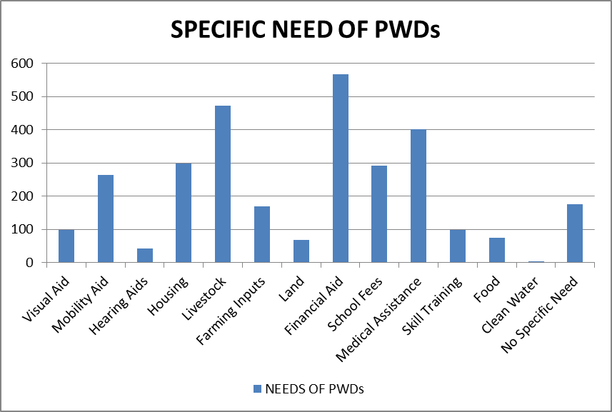
From the table and bar graph above, the PWDs in Nwoya Distriect needed various forms of help. Financial aid, livestock and medical assistance were reported to the most needed forms of help (18.7%, 15.6% and 13.3% respectively). Meanwhile, the least forms of specific help needed were reported to be clean drinking water (0.1%).and land (2.4%).
The needs for assistive devices (for mobility, hearing and visual) and medical assistance/treatment/rehabilitation were alltogether contributing to a total of 26.7% of the total needs reported by the PWDs.
15. PERSONS WHO HELP PWDs WITH THEIR DAILY NEEDS
The respondents were asked to report the person who always provided help with their daily needs. Again, this was found to vary from parish to parish as shown in the Table in Appendix 15. However, the overall findings are shown in the table and Bar Chart below.

TABLE SHOWING PERSONS WHO HELP PWDs WITH THEIR DAILY NEEDS
 | Who usually helps you with your daily needs?
 | Count | % of the Respondents
Family members | 2,632 | 87.56%
Other relatives | 227 | 7.55%
Local community leaders | 37 | 1.23%
Representatives of PWDs | 11 | 0.37%
District/Sub-county LG representatives (CDO) | 6 | 0.20%
Religious institutions | 25 | 0.83%
Local groups/associations where I belong | 18 | 0.60%
Others (Not pecified) | 50 | 1.66%
Total | 3,006 | 100%

BAR GRAPH SHOWING PERSONS WHO HELP PWDs WITH DAILY NEED
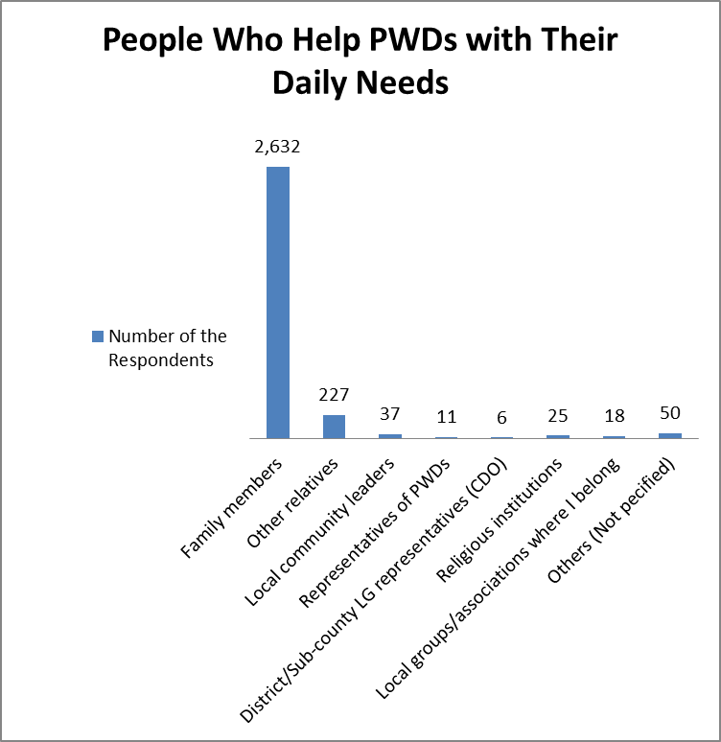
Results in the table and bar graph above show that an overwelming majority (95.1%) reported that their family members (nuclear and extended family) provided them with their daily needs. This was followed by local community leaders (1.2%). The other groups of persons accounted for less than 1% each whereas 1.7% of PWDs did not disclose the specific people/institutions that helped them with their daily needs.
16. THE FREQUENCY OF RECEIVING HELP
The respondents were asked to report how frequently they got help/support and encouragement from the categories of persons mentioned above. Their responses were analysed and found to vary from home parish to home parish as shown in the table in Appendix 16. However, the overall findings are shown in the table and Pie Chart below.

TABLE SHOWING THE FREQUENCY OF PWDs RECEIVING HELP
 | How often do you get help/support and encouragement from the above categories of persons (selected)? |  |  |  | Total
 | Never get | Occasionally | Regularly get | Always get | Total
Count | 303 | 849 | 659 | 1,173 | 2,984
% of the Respondents | 10.15% | 28.45% | 22.08% | 39.31% | 100.00%

PIE CHART SHOWING THE FREQUENCY OF PWDs RECEIVING HELP
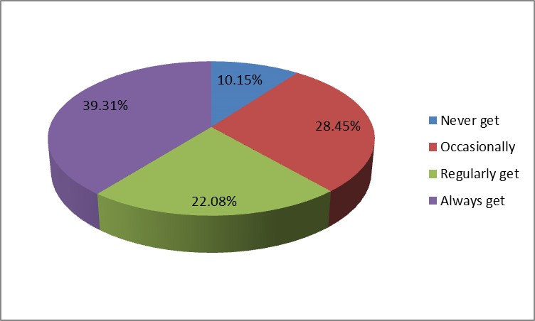
Overall, it was found that 10.2% of the PWDs in Nwoya District never received help, 28.5% received help occasionally and 22.1% reported that they regularly received help. Meanwhile, only 39.3% reported that they always received help whenever they needed it.
17. MAIN SOURCES OF LIVELIHOOD OF PWDs
The respondents were also asked to report on the main source/sources of their livelihood. Their responses were analysed and found to vary from home parish to home parish as shown in the table in Appendix 17. However, the overall findings are shown in the table and Bar Chart below.

TABLE SHOWING THE MAIN SOURCES OF LIVELIHOOD OF PWDs
 | What is your main source of livelihood? |  |  |  |  | Total
 | None | Petty business | farming | casual jobs | professional worker | Total
Count | 841 | 185 | 1,868 | 98 | 14 | 3,006
% of the Respondents | 27.98% | 6.15% | 62.14% | 3.26% | 0.47% | 100.00%

BAR GRAPH SOWING SOURCES OF LIVELIHOOD OF PWDs
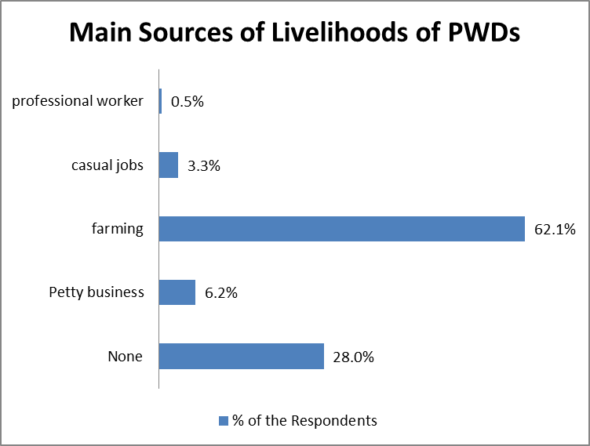
Findings in the the table and the bar graph above reveal that the majority (62.1%) of PWDs in Nwoya District depended on farming as their main source of livelihood. It was also noted that 28% had no clear source of livelihood. Meanwhile, only 0.5% of the PWDs depended on professional work/employment as their main source of livelihood whereas 3.3% engaged in casual work for their livelihood.

18. PRESENT ENGAGEMENT OF PWDs
The study also sought to find out the kind of activity the respodnets were enganed in currently. Their responses were analysed and found to vary from home parish to home parish as shown in the table in Appendix 18. However, the overall findings are shown in the table and Bar Chart below.
TABLE SHOWING THE PRESENT ENGAGEMENT OF PWDs
 | Which of the following best describes what (you) (are) mainly doing at present?
 | Count | % of the Respondents
Studying or training | 138 | 5.01%
Engaged in household or family responsibilities | 665 | 24.14%
Farming or fishing to produce food for the family | 1,232 | 44.72%
Retired or pensioner | 7 | 0.25%
With a long-term illness, injury or disability | 333 | 12.09%
Doing volunteering, community or charity work | 28 | 1.02%
Engaged in cultural or leisure activities | 11 | 0.40%
Other (Not specific on what I do) | 341 | 12.38%
Total | 2,755 | 100%

BAR GRAPH SHOWING THE PRESENT EGAGEMENTS OF PWDs
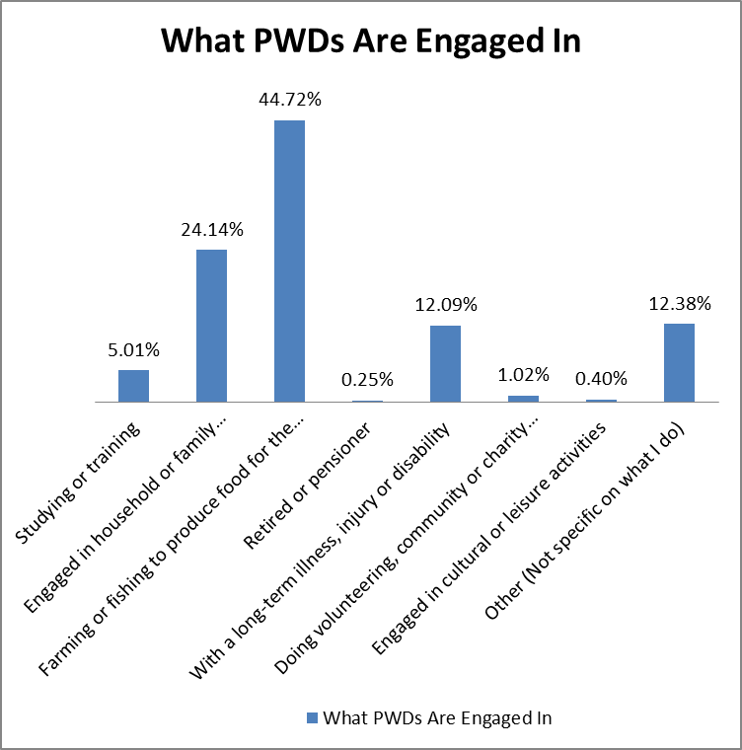
From the table and bar grah above, farming or fishing was reported to be the actvivity that most respondnents (44.7%) were engaged in. This was reported to be followed by those who were engaged in family responsibilities (24.1%). It was also noted that a reasonable proportion of 12.3% were not engaged in any specific activity whereas 12.1 % of the PWDs were not engaged in any livelihood actiivty due to long-term illness or injury or disability.
19. SOURCES OF INCOME IN THE LAST 12 MONTHS
The study also sought to establish the main sources of income in the last 12 months. Again, their responses were analysed and found to vary from home parish to home parish as shown in the table in Appendix 19. However, the overall findings are shown in the table and Bar Chart below.

TABLE SHOWING THE SOURCES OF INCOME IN THE LAST 12 MONTHS
 | In the last 12 months, what has been your Household’s source of income/livelihood?
 | Count | % of the Respondents
Income from household farming or fishing | 1,581 | 65.74%
Income from a household business (other than farming or fishing) | 190 | 7.90%
Income from a paid job (held by a household member or yourself) | 101 | 4.20%
Food produced by the household from farming, raising animals or fishing | 486 | 20.21%
Support from people living abroad | 19 | 0.79%
Support from other households in the country | 17 | 0.71%
Income from properties, investments or savings | 4 | 0.17%
Private or state pension or (other Government support) | 4 | 0.17%
Charity from NGOs or other charitable organizations | 3 | 0.12%
Total | 2,405 | 100%

BAR GRAPH SHOWING SOURCES OF INCOME IN THE LAST 12 MONTHS
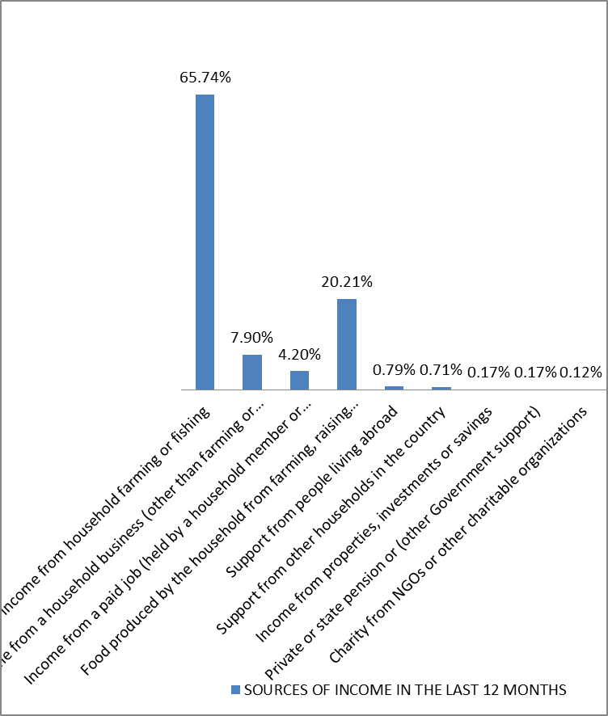
Findings in the table and Bar graph above reveal that the major source of income in the last 12 month for the PWDs was income from household farming (65.7%) followed by food produced by the housholds on farms (20.2%) and income from houshold business (7.9%). It was also noted that only 4.2% of the PWDs in Nwoya District reported that their income was from paid employment.
20. CHANGES IN THE INCOME LEVEL OF PWDs SINCE THE ONSET OF LOCK DOWN ON 20TH MARCH 2020
The study sought to establish whether there were changes in the level of income of PWDs since the onset of lockdown in Uganda due to covid-18 pandemic. Again, their responses were analysed and found to vary from home parish to home parish as shown in the table in Appendix 20. However, the overall findings are shown in the table and Pie Chart below.

TABLE SHOWING CHANGES IN THE INCOME LEVEL OF PWDs SINCE THE ONSET OF LOCK DOWN ON 20TH MARCH 2020
 | Since the onset of lockdown in Uganda; i.e. March 20, 2020, how has your main income source/amount changed? |  |  |  | Total
 | Increased | Stayed the same | Reduced | Total loss/No Earning | Total
Count | 70 | 446 | 1,565 | 586 | 2,667
% of the Respondents | 2.6% | 16.7% | 58.7% | 22.0% | 100.0%

Findings in the table above and the pie chart below revealed that the majority of the respondents(58.7%) reported a reduction in the level of their income and 16.7% reported that there was no change on the level of their income. Although 2.6% reported an increase in the level of their income, a sizeable proportion of 22% reported a total loss in their income.
BAR GRAPH SHOWING THE CHANGES IN INCOME LEVEL OF PWDs SINCE THE ONSET OF LOCK DOWN ON 20TH MARCH 2020
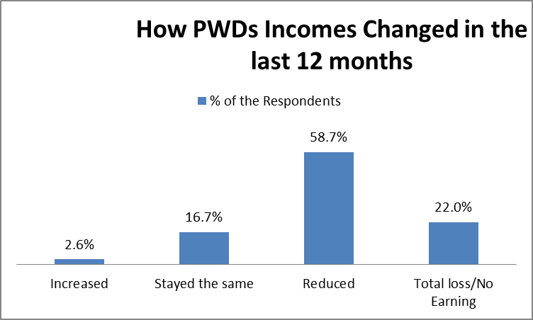
21. POSSIBLE REASONS FOR THE REDUCTION IN INCOME LEVELS OF PWDs
The study also wanted to find out the major reasons for the changes(reduction) in the level of income of PWDs in Nwoya District since the onset of lockdown in Uganda. Again, their responses were analysed and found to vary from home parish to home parish as shown in the table in Appendix 21. However, the overall findings are shown in the table and Bar Graph below.
TABLE SHOWING POSSIBLE REASONS FOR REDUCTION IN INCOME LEVELS OF PWDs
 | Why has the income reduced/No Earnings?
 | Count | % of the Respondents
Usual place of business closed due to Corona Virus legal restrictions | 477 | 19.31%
Usual place of business closed for Another reason | 105 | 4.25%
No customers / fewer customers | 171 | 6.92%
Can't get inputs | 304 | 12.31%
Can't travel / transport goods for trade | 325 | 13.16%
Ill / quarantined due to Corona Virus | 214 | 8.66%
Ill with another disease | 230 | 9.31%
Laid off while business continues | 14 | 0.57%
Seasonal /Not farming season | 247 | 10.00%
Other (specify) | 383 | 15.51%
Total | 2,470 | 100%

PIE CHART SHOWING POSSIBLE REASONS FOR REDUCTION IN INCOME LEVEL
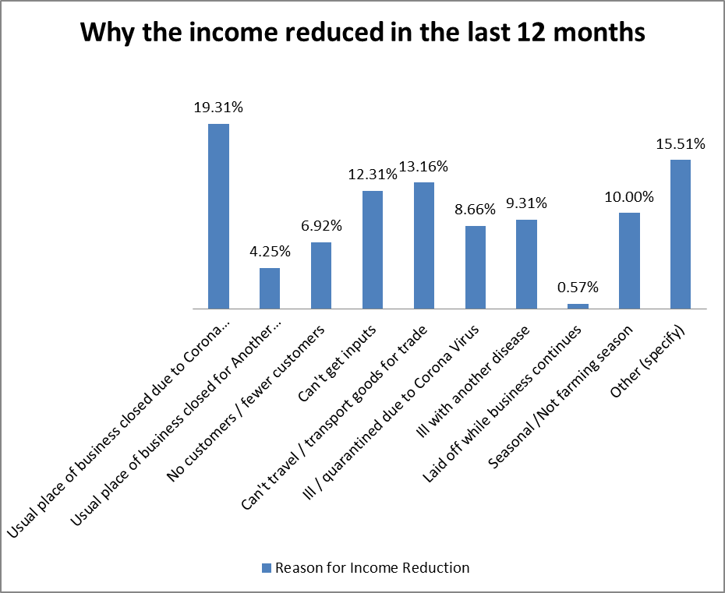
From both the table and Bar Graph above, the closure of usual places of business due to Corona Virus legal restrictions was cited as the strongest reason (19.3%) for the reduction of income level of PWDs. This was followed by inability to travel and transport the goods from one place to another (13.2%) and inability to get inputs of the business (12.3%). Other reasons, which were not specified, accounted for 15.5%.
22. PROBLEMS FACED BY PWDs IN ENGAGING IN ECONOMIC ACTIVITIES
The respondents were asked to report the most pressing challenges they faced in engaging in their economic activities. Their responses were analysed and shown in the table in Appendix 22 as well as in the Bar Chart below.

BAR GRAPH SHOWING PROBLEMS FACED BY PWDs WHILE ENGAGING IN ECONOMIC ACTIVITIES
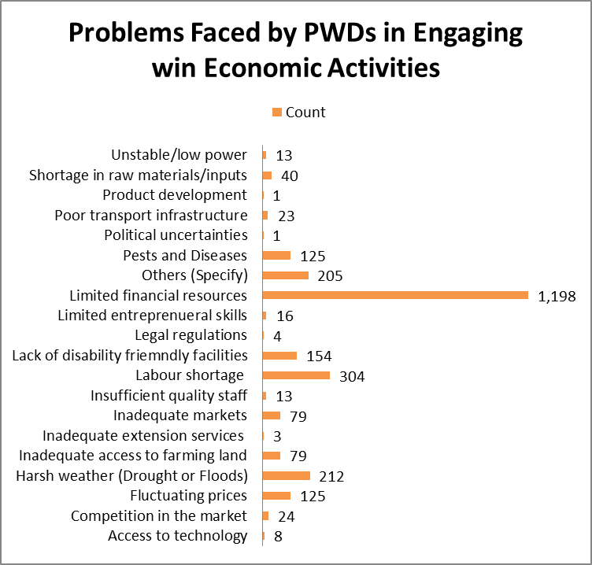
Limited Financial resources were reported to be the most pressing challenge faced by 1,198 PWDs when engaging in their economic activities. This was followed by shortage of labour to be employed in the economic activity (304 PWDs) and harsh weather/droughts and floods (212 PWDs).
23. SUBJECTED TO THE FOLLOWING ABUSE IN THE PLACE OF WORK OR COMMUNITY
The respondents were asked to report if they had ever been subjected to various forms of abuse in their places of work or in the community. Their reponses are shown in the table below.

TABLE SHOWING FORMS OF ABUSE IN THE PLACE OF WORK OR COMMUNITY
In the last 12 months, have you ever been subjected to the following at your workplace or community?
 | Constantly shouted at |  | Repeatedly insulted |  | Beaten /physically hurt |  | Sexually abused (touched, said or did things to you) |  | Financial Abused (Not paid for services offered)
 | Frequency | Percent | Frequency | Percent | Frequency | Percent | Frequency | Percent | Frequency | Percent
YES | 1,378 | 46 | 1,573 | 52 | 695 | 23 | 140 | 5 | 336 | 11
NO | 1,647 | 54 | 1,452 | 48 | 2,330 | 77 | 2,885 | 95 | 2,689 | 89
TOTAL | 3,025 | 100 | 3,025 | 100 | 3,025 | 100 | 3,025 | 100 | 3,025 | 100

BAR GRAPH SHOWING FORMS OF ABUSE EXPERIENCED BY PWDs
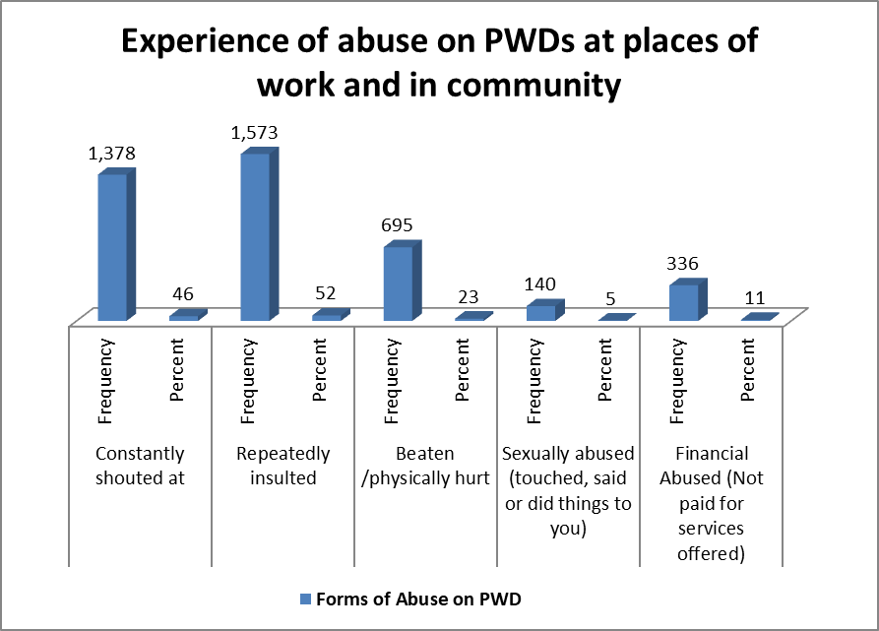
From the table and bar graph above, it can be observed that repeated insult was most common form of abuse that PWDs expereinced in the places of work or community (52%). This was followed by being constantly shouted at (46%) and being beaten or physically hurt (23%). The least form of abuse in the places of work was reported to be sexual abuse (5%) followed by financial abuse (11%).
24. OWNERSHIP OF LAND BY PWDs OR FAMILY
The study sought to establish whether or not the PWDs owned land within the communiy in which they lived or elsewhere. Their responses were analysed and found to vary from home parish to home parish as shown in the table in Appendix 23. However, the overall findings are shown in the table and Bar Graph below.
TABLE SHOWING OWNERSHIP OF LAND BY PWDs OR FAMILY
 | Do you /your family own land within the community or elsewhere? |  |  |  | Total number of PWDs in the enumeration
 | Yes | No | No response | Not sure | 3,025
Count | 2,709 | 286 | 11 | 30 | 3,025
% of the Respondents enumerated | 90 | 9 | 0 | 1 | 3,025
Both the Table above show that majority of the PWDs and or their households (90%) owned land in their communities and only 9% did not own land. Meanwhile, there were 1% of PWDs who did not know whether they owned land or not.
25. STATUS OF LAND REGISTRATION
The study also wanted to find out whether the land owned by the PWDs was registered or not. Their responses are shown in the table and pie chart below. Their responses were analysed and found to vary from home parish to home parish as shown in the table in Appendix 24. However, the overall findings are shown in the table and Pie chart below.

TABLE SHOWING THE STATUS OF LAND REGISTRATION
 | Is the land you are owning registered in your names? |  |  |  | Total number of PWDs who owned land as individuals or households
 | Yes | No | No response | Not sure | 2,709
Count | 382 | 2,339 | 153 | 110 | 2,709
% of the Respondents | 14% | 86% | 6% | 4% | 2,709
From both the table above, it was observed that most of the PWDs (86%) reported that the land they owned was not registered at all with any gpvernment authority. Meanwhile, only 14% reported having registered their owned land in their names and 4% of PWDs owning land were not sure of the registration status of the land.
26. GOVERNMENT AUTHORITY FOR LAND REGISTRATION
The study wanted to establish, from those PWDs who registered their land, as to which government structure that they registered their land with. Their responses were analysed and found to vary from home parish to home parish as shown in the table in Appendix 25. However, the overall findings are shown in the table and Bar chart below.
TABLE SHOWING GOVERNMENT AUTHORITY FOR LAND REGISTRATION
 | If Land is registered, with which structure of governance is it registered? |  |  |  | Total number of PWDs whose land are registered in their names
 | Local Government | Area Land Committee | District Land Board | Don’t know
Count | 237 | 213 | 10 | 613 | 282
% of the Respondents | 84% | 76% | 4% | 57 | 282

Findings showed that of the PWDs whose lands are registered in their names, 84% registered their land with the Local Governments, 76% registered their land with the Area Land Committees and only 4% registered their land with the District Land Boards. Meanwhile, overrall, a reasonable proportion of 57% of respondents to this question did not know the governmrnt structure with which their land was registered.
27. CURRENT LAND USE
The study wanted to establish the different uses to which the PDWs put the land that they owned. Their responses were analysed and found to vary from home parish to home parish as shown in the table in Appendix 26. However, the overall findings are shown in the table and Pie chart below.
TABLE SHOWING CURRENT LAND USE
 | What are you using the land for? |  |  |  |  |  | Total
 | Crop farming | Animal farming | Hired out | Tree planting | Not used for anything | Any other, please specify | Total
Count | 2,094 | 343 | 45 | 58 | 112 | 180 | 2,832
% of the Respondents | 74% | 12% | 2% | 2% | 4% | 6% | 100%

BAR GRAPH SHOWING CURRENT LAND USE
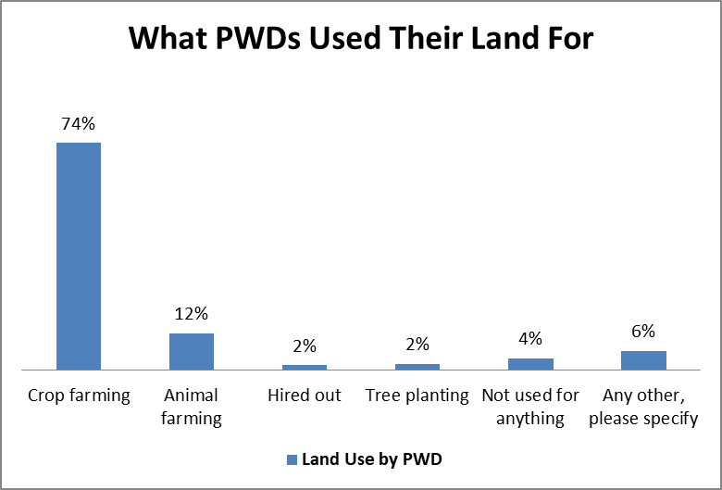
Findings revealed that the majority of PWDs (74%) used the land for crop farming. This was followed by use of land for animal farming (12%). It was also reported that other PWDs never used their land for any activity (4%) and other PWDs hired out their land to be used by others 2%).

28. FEELING OF SAFETY ON LAND
The respondents were asked to report whether they felt safe or not while staying the land together with families. Their responses were analysed and found to vary from home parish to home parish as shown in the table in Appendix 27. However, the overall findings are shown in the table and Pie chart below.
TABLE SHOWING THE FEELING OF SAFELTY ON LAND
 | Do you feel safe on the land you/your family live in? |  |  |  | Total
 | Yes, I Feel Safe | No, I Don't Feel Safe | No response | Not sure | Total
Count | 2,154 | 529 | 291 | 51 | 3,025
% of the Respondents | 71 | 17 | 10 | 2 | 100

PIE CHART SHOWING FEELING OF SAFETY ON LAND
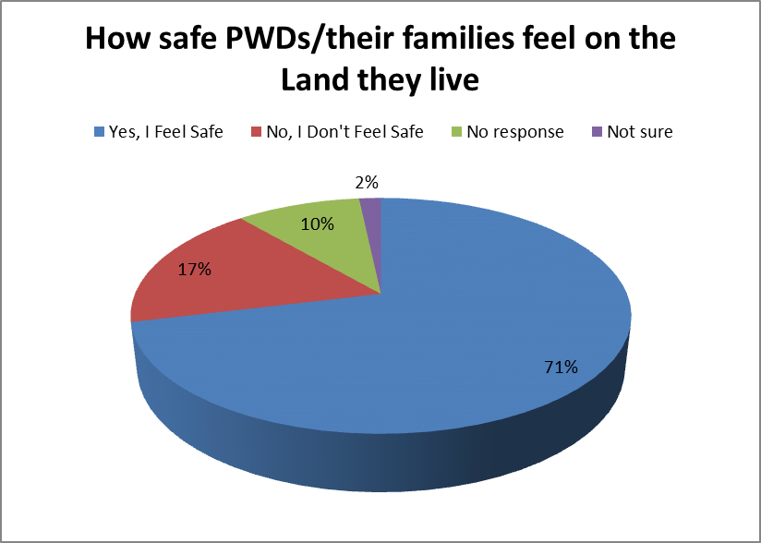
The majority of PWDs (71%) confirmed that they felt safe on the land that they and their families lived in. Meanwhile, 17% did not feel safe at all living safe on the land and 2% neither felt safe nor threatened on their land. 10% of respondents opted not to respond to this question.

29. LAND OWNERSHIP CHALLENGES FACING PWDS
The respondents were asked to report the challenges they faced in owning land in their communities. Different land ownership challenges were reported as shown in the bar graph below.
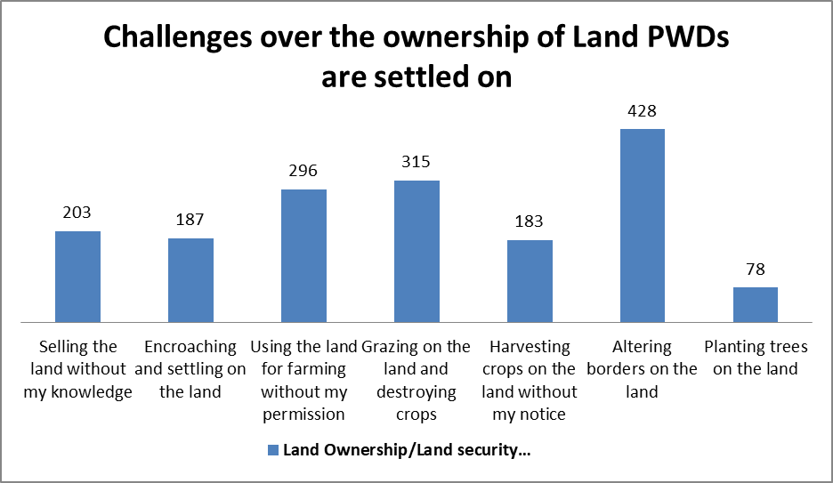
Findings revealed that altering the boarders of land of PWDs was a major challenge reported by 428 respondents. Meanwhile, grazing on the land and destroying crops was also reported as a challenge (315 respondents). Other challenges included the using the land for farming without the permission of PWDs (296 respondents), the selling away of land without the knowledge of PWDs (203 respondents) and encroaching and settling on the land of PWDs (187 respondents).
A total of 384 PWDs had their land ownership/land use/land security challenges resolved using the different mechanisms/structures.
30. GOVERNMENT STRUCTURES USED IN ADDRESSING LAND-RELATED CONCERNS
The respondents were asked to report the government structure that they commonly used in addressing their land-related concerns. Their responses were analysed and found to vary from home parish to home parish as shown in the table in Appendix 29. However, the overall findings are shown in the table and Pie chart below.

TABLE SHOWING GOVERNMENT STRUCTURES USED IN ADDRESSING LAND-RELATED CONCERNS
 | If Yes above, which structures have been supportive in addressing these land-related concerns?
 | Count | % of the Respondents
Local Council I and II offices | 272 | 69%
Community Development Officer | 11 | 3%
Area Land Committees | 7 | 2%
Uganda Police | 6 | 2%
Clan elders and opinion leaders | 43 | 11%
Family members (Uncles, Aunties, grannies | 57 | 14%
Total | 396 | 100%

BAR GRAPH SHOWING GOVERNMENT STRUCTURES USED IN ADDRESSING LAND-RELATED CONCERNS
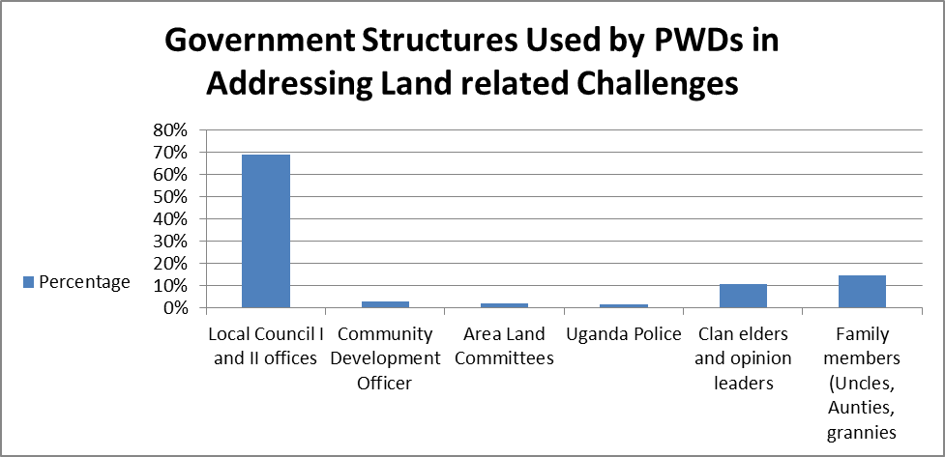
From the table and bar graph above, LCI and II are the most commonly used government structure by PWDs in Nwoya District when settling their land-related concerns (69%). This was found to be followed by family members like aunts and grandparents (14). The use of Uganda Police was found to the least at only 2%.
31. SHOWING MEMBERSHIP TO PERSONS WITH DISABILITY ORGANISATION (OPD)
The study sought to establish if the respondents were registered members of Persons with Disability Organizations (OPD). Their responses were analysed and found to vary from home parish to home parish. However, the overall findings are shown in the table and Pie chart below.
TABLE SHOWING MEMBERSHIP TO PERSONS WITH DISABILITY ORGANISATION (OPD)
Membership in OPD
 | Count | Percentage
Yes | 591 | 20
No | 2,305 | 76
Not Sure | 102 | 3
No Response | 27 | 1
Total | 3,025 | 100

PIE CHART SHOWING THE MEMBERSHIP TO DISABLE PERSONS ORGANISATION (DPO)
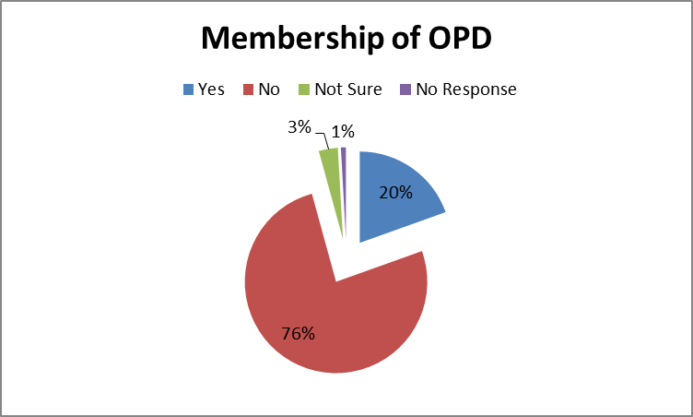
The majority of PWDs in Nwoya District (76%) reported that they were not members of any OPD in their district and only 20% reported that they had joined some OPDs as members. Meanwhile, 3% of the PWDs were not aware of any OPDs that existed in their district.
32. ACTIVITIES ENGAGED IN DISABLE PERSONS ORGANISATIONS (DPO)
Those PWDs IN Nwoya District who were members of OPD were further asked to report on the kind of activities engaged in within the OPD. Their responses were analysed and found to vary from home parish to home parish as shown in the table in Appendix 31. However, the overall findings are shown in the table and Bar graph below.
TABLE SHOWING ACTIVITIES ENGAGED IN DISABLED PERSONS ORGANISATIONS (DPO)
 | What activities are you engaged in within the OPD? |  |  |  |  |  | Total
 | Nothing | group meetings | Savings and Credit | Farming (crop/Animal) | Joint businesses | training and skills development | Total
Count | 2,393 | 176 | 372 | 50 | 2 | 7 | 3,000
% within of the Respondents | 80% | 6% | 12% | 2% | 0% | 0% | 100%

Findings showed that, the majority (80%) of PWDs who were members of OPDs reported that they were not engaged in any meaningful activity. Only 12% of PWDs were reported to be engaged in savings and Credit activities within the OPD and 6% were engaged in group meetings. Meanwhile, 2% were reported to be engaged in farming activities.
33. GOVERNMENTAL AND OTHER AUTHORITIES THAT INTERACTED WITH ORGANISATIONS OF PERSONS WITH DISABILITIES
The PWDs IN Nwoya District were also asked to report the government and other authorities that they interacted with most frequently as members of OPDs in relation to PWDs’ needs. Their responses were analysed and found to vary from home parish to home parish. However, the overall findings are shown in the table and Bar graph below.

TABLE SHOWING GOVERNMENTAL AND OTHER AUTHORITIES THAT INTERACTED WITH ORGANISATION OF PERSONS WITH DISABILITIES
 | Count | % of the Respondents
LC I & II leaders | 1,225 | 40%
CDO/Parish Chiefs | 178 | 6%
Representatives of PWDs | 147 | 5%
Sub County Union of PWDs | 33 | 1%
Religious leaders | 153 | 5%
Cultural leaders | 87 | 3%
Teachers | 16 | 1%
Not sure | 280 | 9%
Don’t know | 906 | 30%
Total | 3,025 | 100%
LCI and LCII Leaders were the authorities that PWDs interacted with the most as reported by 40% of the respondents. This was followed by CDO/Parish Chiefs (6%), Religious Leaders (5%) and Representatives of PWDs (5%).
34. ABILITY TO REACH PWD REPRESENTATIVES
The PWDs in Nwoya District were asked to report whether they were able to reach out to the PWD representatives and share or receive feedback on services they needed. Their responses were analysed and found to vary from home parish to home parish as shown in the table in Appendix 33. However, the overall findings are shown in the table and Bar graph below.

TABLE SHOWING ABILITY TO REACH PWD REPRESENTATIVES
 | Do you feel you are able to reach PWD representatives (Councilors and DPOs) to share report and/or receive feedback on services you need at any time? |  |  |  |  | Total
 | Never | Rarely | Sometimes | Often | Always | Total
Count | 1,145 | 646 | 553 | 131 | 161 | 2,636
% of the Respondents | 43% | 25% | 21% | 5% | 6% | 100%

PIE CHART SHOWING THE ABILITY TO REACH THE PWD REPRESENTATIVES
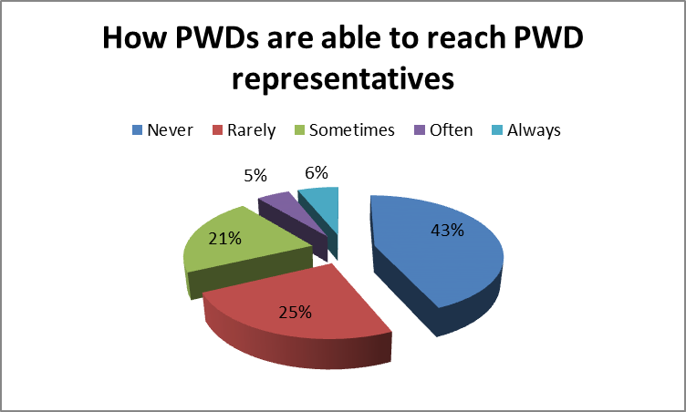
The findings revealed that 43% of PWDs never felt able to reach out their Representatives. Meanwhile, 25% reported that they rarely reached out to their representatives. Only 6% reported that they always reached out to PWD Representatives.

35. EXTENT OF TO WHICH PWDs FEEL THEIR NEEDS ARE TAKEN SERIOUSLY BY PUBLIC AUTORITIES THEY REACHED OUT TO
How PWDs feel their needs are taken seriously by public authorities
 | Count | Percentage
Always | 187 | 7
Never | 1,077 | 40
Often | 221 | 8
Rarely | 634 | 23
Sometimes | 600 | 22
Total | 2,719 | 100
According to the table above and Pie Chart below, Majority (40%) of PWDs in Nwoya felt their needs are never taken seriously by public authorizes whereas 7% of PWDs felt that their needs were always taken seriously by public authorities. Also, 22% and 23% of PWDs felt that their needs were sometimes and rarely taken seriously by public authorities respectively.
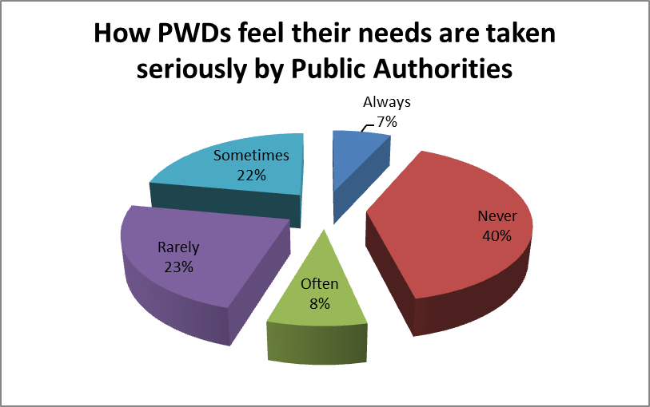

36. EXTENT OF SATISFACTION WITH ACCESS AND CONVENIENCE OF UTILIZING FACILITIES IN PUBLIC PLACES
The PWDs IN Nwoya District were asked to report on the extent of their satisfaction with accessing and convenience of utilizing a number of facilities in public places. These facilities and their responses are shown in the table below.

TABLE SHOWING THE EXTENT OF SATISFACTION WITH ACCESS AND CONVENIENCE OF UTILIZING FACILITIES IN PUBLIC PLACES
 | Buildings and other public facilities are accessible e.g with ramps for easy access |  | The sanitary facilities e.g toilets can easily be used by PWDs |  | Signs and or marks to direct persons with disabilities |  | Guide/support at service points for PWDs while at public places with appropriate information |  | Free participation of PWDs in community life and events
 | Frequency | Percent | Frequency | Percent | Frequency | Percent | Frequency | Percent | Frequency | Percent
Very dissatisfied | 856 | 28 | 844 | 28 | 965 | 32 | 864 | 29 | 583 | 19
Dissatisfied | 438 | 14 | 434 | 14 | 659 | 22 | 751 | 25 | 527 | 17
Not sure | 1,219 | 40 | 1,290 | 43 | 1,007 | 33 | 1,067 | 35 | 1,377 | 46
Satisfied | 324 | 11 | 282 | 9 | 260 | 9 | 221 | 7 | 222 | 7
Very satisfied | 188 | 6 | 175 | 6 | 134 | 4 | 122 | 4 | 316 | 10
Total | 3,025 | 100 | 3,025 | 100 | 3,025 | 100 | 3,025 | 100 | 3,025 | 100

Findings in the table above show that there were variations in the extent of satisfaction among PWDs concerning access and convenience of use of public facilities as discussed below.
- Buildings and other public facilities are accessible e.g with ramps for easy access. About 11% of the PWDs reported that they were satisfied with the access and convenience of using buildings in public places. Meanwhile, 28% reported that they were very dissatisfied.
- The sanitary facilities. Those who were not satisfied with the access and convenience of sanitary facilities in public places were reported to be (9%) than those who were reported to be very dissatisfied (28%). Meanwhile, the 43% were not sure.
- Signs and or marks to direct persons with disabilities. As much as 22% of the PWDs reported that they were not satisfied with signs and marks in public places put to direct persons with disability. Only 9% of the PWDs reported that they were satisfied with the signs and or marks to direct persons with disabilities.
- Guide/support at service points for PWDs while at public places. Findings show that about 25% of PWDs were not satisfied with the guide and support given to them while at public places. Meanwhile, about 7% were reported to be satisfies with the guide and support they received while in public places and the 35% were not sure.
- Free participation of PWDs in community life and events. From the findings, only 17%% were satisfied (satisfied and very satisfied) with the level of freedom of PWDs to participate in community life and events while 37% were reported to be dissatisfied (dissatisfied and very dissatisfied). 46% were not sure of their level of satisfaction with free participation of PWDs in community life and events.

END OF REPORT

NUDIPU estimates that in every Village/Cell there is a maximum average of 30 PWDs.
Percentage of total respondents to the question

